Fun-Zone

|  |  |  |
| --- | --- | --- |
| **Supervisor.** | **Sir Muhammad Hamza** | |
| **Batch.** | **2309G3** | |
| **Group.** | C | |
| **Serial No.** | **Enrollment Number** | **Student Name** |
| 1. | 1507026 | Muhammad Umair |
| 2. | 1508383 | Shahzaib Ali Zahid |
| 3. | 1507111 | Abdul Ahad Hussain |
| 4. | 1501118 | Muhammad Shafay Shaikh |

**ACKNOWLEDGEMENT**

Before anything, I would like to thanks my beloved teacher who helped us a lot in reviewing this project within the limited time frame.

Secondly, we would also like to thank the E-Project team at Aptech Head Office, who gave us the golden opportunity to do this project of FUNZONE.

Thirdly, we also thank the E-Project team, some of the benefits are as under: Re-enforcement of skills happens in the experiential learning process. ∙ A mentor, ensuring that we do not get drifted, constantly guides us. ∙ It gives us a lot of confidence to face an interview as we have worked on a project. We can explain virtually everything on the subject we have worked on.

***PROBLEM DEFINITION***

The ‘FUN ZONE’ Most Entertaining Theme Park, is one of the best ideas executedin

the amusement &amp; entertainment industry. It caters to everyone, be it a child who

seeks entertainment or an adult who wishes for a pleasant evening. This initiative is

aimed towards providing its visitors with ample elements to spend a quality day. It

promises fun and frolic packed with adventurous and elegant ambience.

It has 7 different internationally themed zones which will keep you occupied for the

entire day. You will never fall short of excitement or thrills, thanks to the mascots

that will make sure you are treated with the best of hospitality. There are zones like

thrill rides, 7 wonders of the world, a massive food court and other areas ensuring

360 degrees of sheer entertainment.

***CUSTOMER REQUIREMENT***

***SPECIFICATION (CRS)***

The Web site is to be created based on the following requirements.

1) The Home Page should be created with sections, graphics and with a suitable

logo

2) The site should display a menu with following categories:

• EXPERIENCE

• LEISURE &amp; DINNING

• PARKS CHARACTERS

• WHATS UP

• PARK INFORMATION

• BUSINESS OPPORTUNITIES

3) ‘EXPERIENCE’

menu option should provide an overview of the entire park with

proper maps and brief information on the sections in park.

4) ‘LEISURE & DINNING’

menu option should provide information on food section

with outlet details. It can also be organized brand wise. When a user selects

any particular brand, a list of products for that brand will be displayed

5) ‘PARKS CHARACTERS’

menu option should provide details about the

characters in the parks and a small story should be associated to them.

6) ‘WHATS UP’

should provide details of past and upcoming events.

7) There should be a “Contact Us” page which will have the Address of the

Company which is as follows and the mail address which when clicked will

invoke the local mail client from where they can send an email.

***SCOPE OF THE WORK (IN BRIEF)***

The scope of a Fun Zone Park includes defining its purpose (e.g., family entertainment, adventure), planning attractions and layout, identifying the target audience, integrating technology, ensuring safety measures, providing accessibility, planning marketing, establishing a budget, considering environmental impact, complying with regulations, and engaging the local community

***AGGREGATED SITEMAP***

***WIREFRAMES***

NAVBAR:

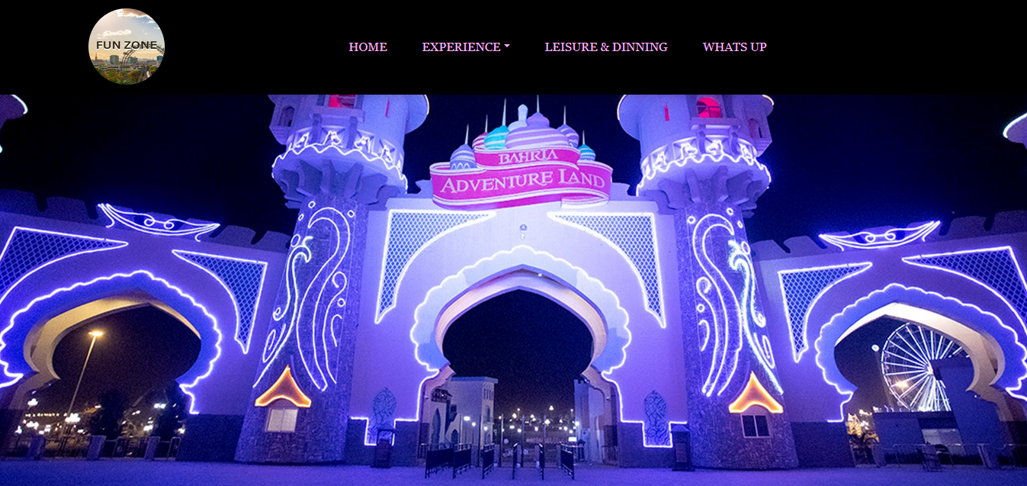

Park Character:

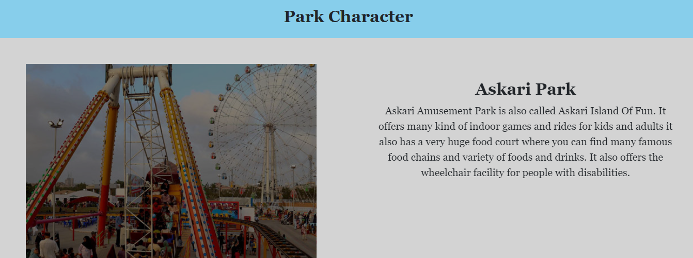

WHATS,UP

location

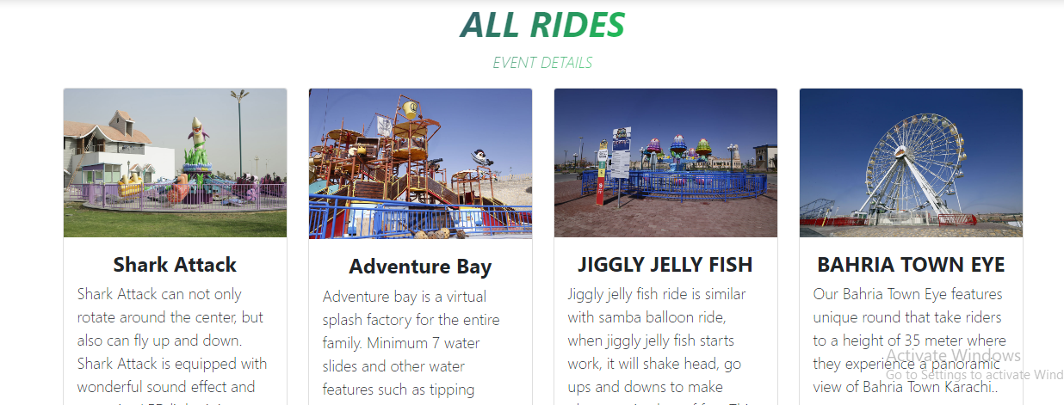

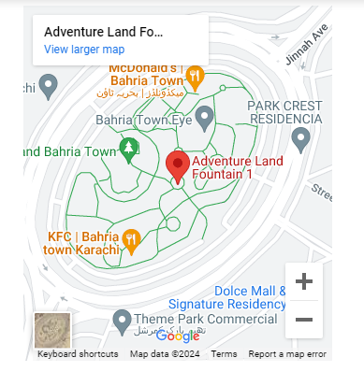

LEISURE&DINNIG:

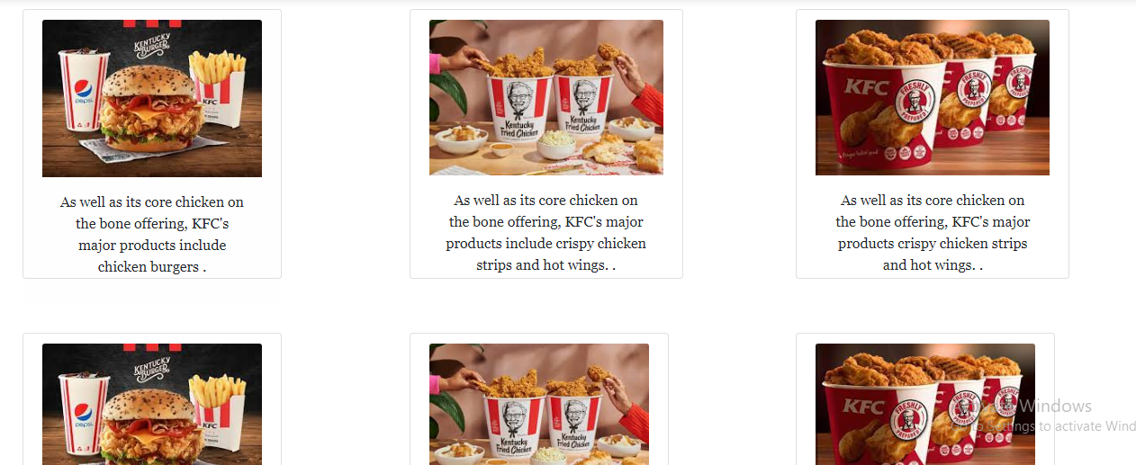

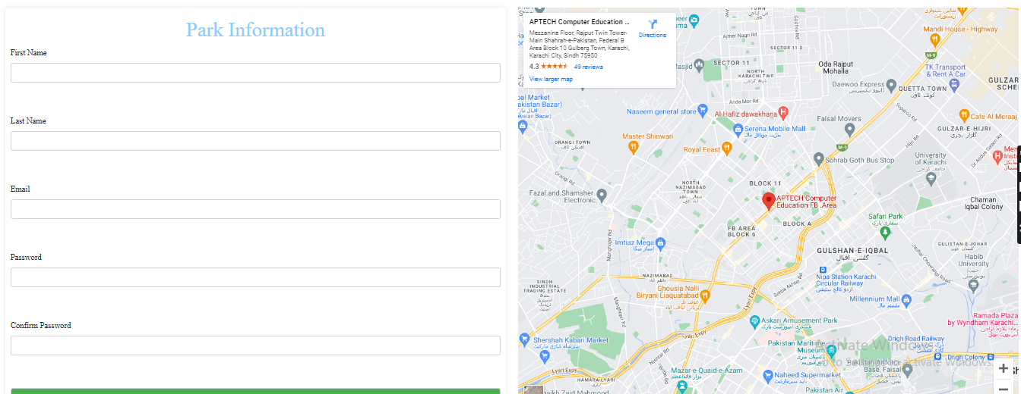

CONTACT:

FOOTER:

